PHASE 2: REQUIREMENT ANALYSIS PHASE

Functional Requirements
The project requires the following functionalities:

1. Employee Data Spreadsheet
The input data is prepared in a spreadsheet containing employee information.
The required employee fields are:
- Employee ID
- Employee Name
- Email
- Department
- Location

2. Custom Employee Table
A custom table named Employee Test is created in ServiceNow.
Table Name: u_employee_test
The table contains the required employee fields.

3. Import Set Table
An Import Set table named Employee Import is created to temporarily store the spreadsheet data before transformation.
Name: u_employee_import

4. Transform Map
A Transform Map is required to connect the source Import Set table with the target Employee Test table.
Transform Map Name: Sample Spreadsheet Import
Source Table: Employee Import
Target Table: Employee Test

5. Duplicate Prevention
The project requires Coalesce functionality to prevent duplicate employee records when the same data is imported multiple times.

6. Reporting and Dashboard
Reports are required for:
- Employees by Department
- Employees by Location
- Employee List
These reports are then added to an Employee Analytics Dashboard.
Create new Custom table
Navigation:
- Tables > Create New
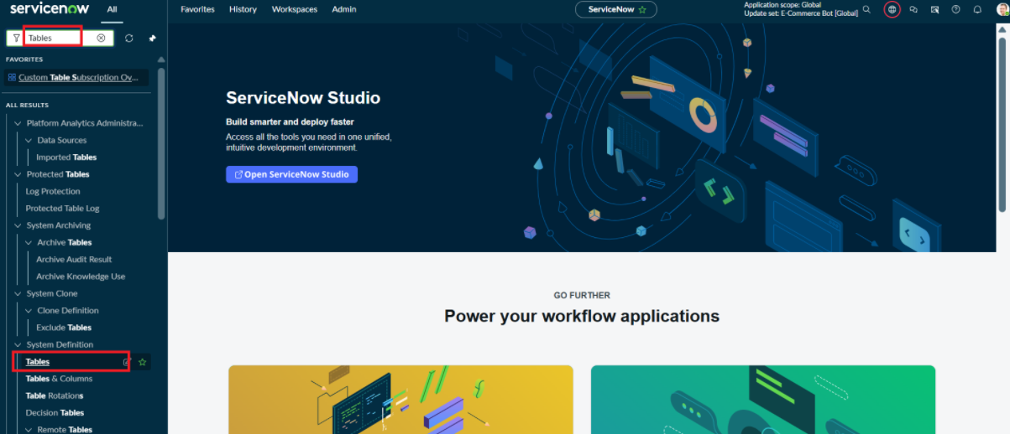
- Label: Employee Test
- Name: u_employee_test
- After creating and saving the Employee Test table, scroll down to the bottom of the table form.
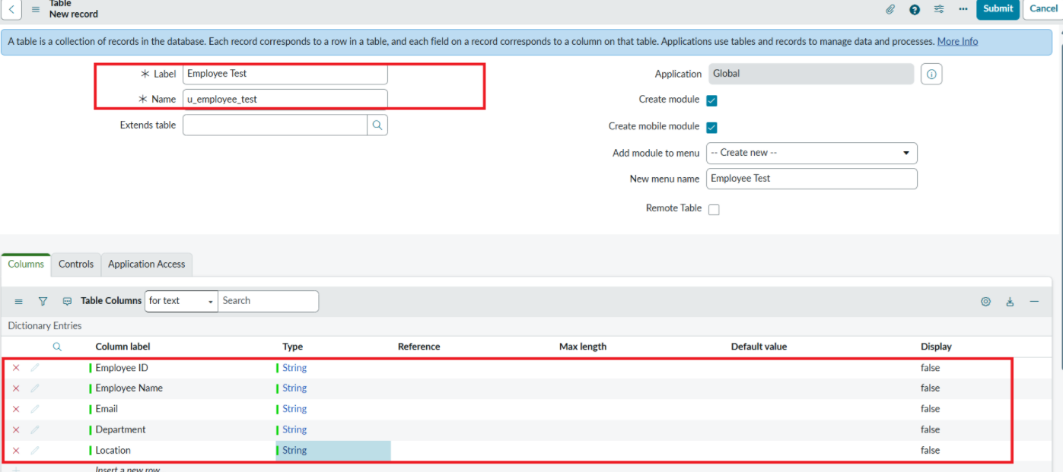
- Click Show Form to open the table form.
- On the form, locate the Form Context Menu / Additional Actions option on the left side of the form header.
- Click the Form Context Menu / Additional Actions icon.
- Click configure , select Form Layout.
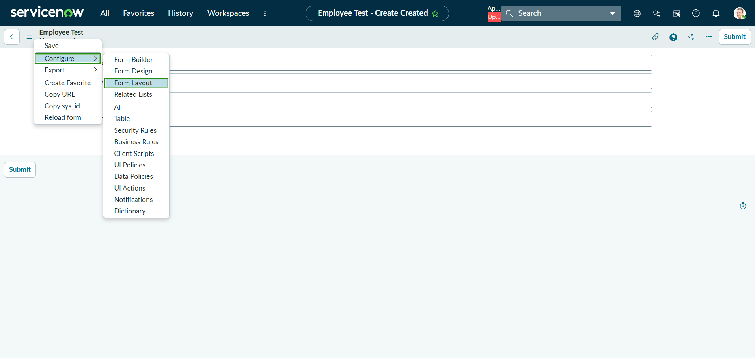
- The Form Layout page will open, where you can configure the fields displayed on the form
- After opening Form Layout, click New to create a new field.
- Enter the field details:
- Column Label: Employee ID
- Type: String
- Click Add to create the field.
- Repeat the same steps to create the following fields:
  - Employee Name – Type: String
  - Email – Type: String
  - Department – Type: String
  - Location – Type: String
- After creating all the required fields, click Save.
- Verify that the newly created fields are displayed on the Employee Test form.
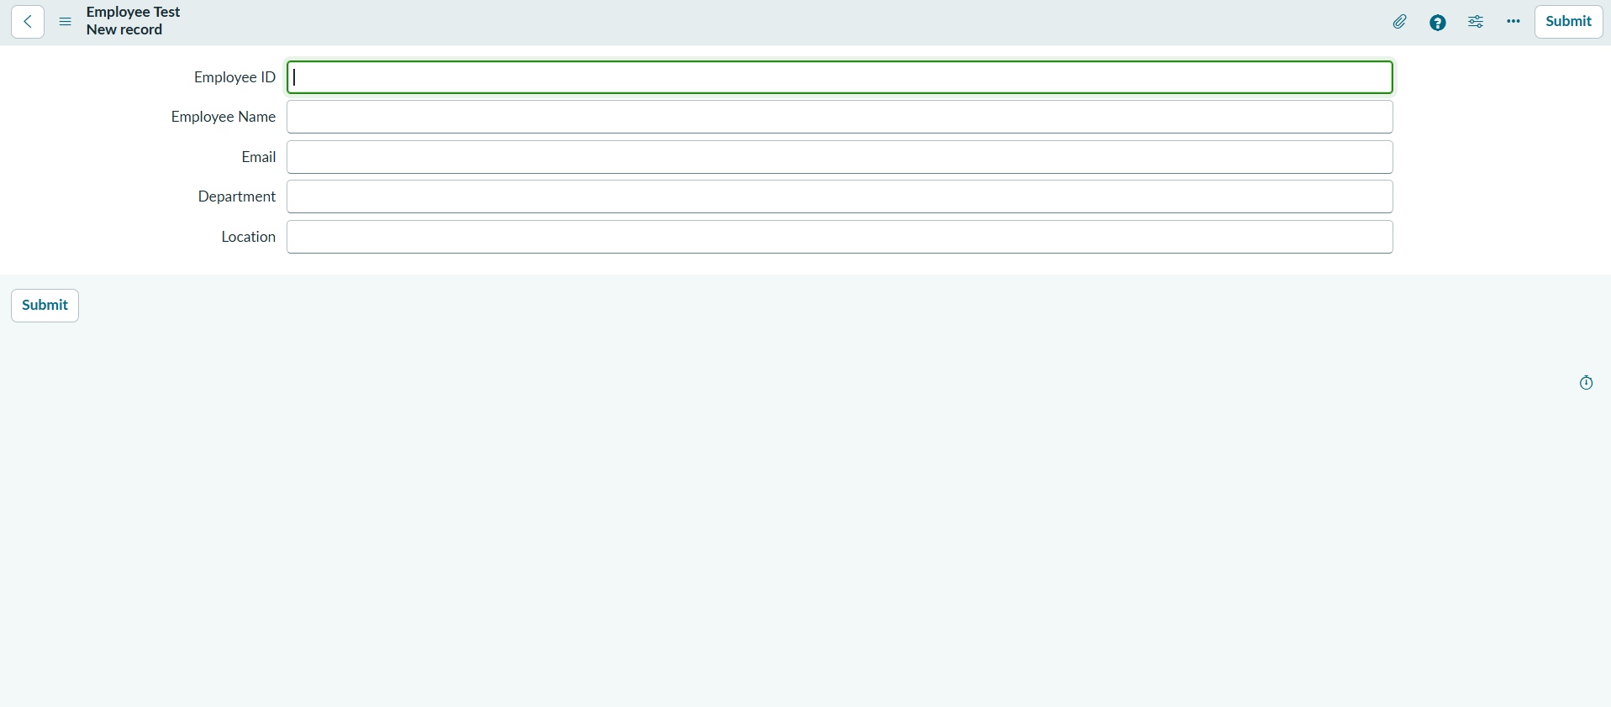

Click on Submit or Save.

